# Appendix C

# ANTIMICROBIAL RESISTANCE AND GENOMIC INSIGHTS INTO *CAMPYLOBACTER* *COLI* ISOLATES FROM AUSTRALIAN PIGS

Nikki Owiredu1,2,3, Soo Sum Lean1, Hui San Allison1,2, David Jordan1, Sam Abraham1,2*±, Rebecca Abraham1,2*±

**1**Centre for Biosecurity and One Health, Harry Butler Institute, Murdoch University, Perth 6150, Australia

2 School of Medical, Molecular, Forensic Sciences, Murdoch University

3 Council for Scientific and Industrial Research-Animal Research Institute, P.O. Box AH20, Achimota, Ghana

**\*Corresponding author:** [S.abraham@murdoch.edu.au](mailto:S.abraham@murdoch.edu.au), [R.abraham@murdoch.edu.au](mailto:R.abraham@murdoch.edu.au)

± These authors contributed equally to the work

# ABSTRACT

This comprehensive Australia-wide study aimed to determine the frequency of carriage of *Campylobacter* in pigs, their antimicrobial resistance profiles and genomic characteristics. Faeces from 300 pigs were cultured and a 72.7% prevalence of carriage for *Campylobacter coli* was found, with no *Campylobacter jejuni* identified. Dilutions of 11 antimicrobials were prepared on a Robotic Antimicrobial Susceptibility platform and tested against the isolates using the broth microdilution technique. High rates of resistance to azithromycin (64.1%), clindamycin (60.2%), erythromycin (58.3%) and tetracycline (56.9%) were recorded, whilst resistance to fluoroquinolone was found in 11.5% despite the absence of its use in Australia. In contrast, low rates of resistance were found for chloramphenicol, nalidixic acid and florfenicol. Multi-class resistance was detected in 48.8 % of the isolates. Genome analysis revealed 38 known sequence types (STs), the majority of which belonged to the 828 clonal complex. Fluoroquinolone resistance was encoded by a mutation in the QRDR of the DNA gyrase, whilst A2075G mutation in the 23rRNA gene accounted for the observed macrolide resistance. Compared to *C. coli* isolates from Australian meat chickens, which have been shown to be commonly susceptible to most antimicrobials tested, the *C.* isolates from pigs showed much higher rates of resistance. This difference is likely to reflect the greater exposure of pigs to antimicrobials compared to young meat chickens. Both species were susceptible to macrolides with very low resistance to tetracyclines. The high rates of resistance to critically important antimicrobials in *C. coli* isolates from pigs is a public health concern and underscores the need to devise interventions to control antibiotic use in the pig industry while safeguarding antimicrobial stewardship.

# 1.0 INTRODUCTION

Campylobacteriosis caused by infection with *Campylobacter jejuni* or *Campylobacter coli* is the most common food-borne zoonosis worldwide [1]*.* *Campylobacter* species colonize the gastrointestinal tract of various warm-blooded animals such as poultry, pigs, sheep, cattle and domestic pet species [2, 3]. Disease is uncommon in these animals, although occasionally infection can cause diarrhoea in young animals and sporadic abortions [4]. Globally, *C.* *jejuni* is the most prevalent species found in poultry, whereas pigs are mostly implicated as reservoirs of *C. coli* [5-7]. Enteric campylobacteriosis is a typical zoonosis that can be transmitted to humans through direct contact with animals, carcasses or indirectly through the ingestion of contaminated food or water [1, 8]. Infected humans may develop diarrhoea, abdominal cramps, fever and vomiting.

*Campylobacter* spp. isolates are increasingly resistant to antimicrobials, particularly fluoroquinolones (ciprofloxacin) and macrolides (erythromycin), which are the most frequently used treatments for campylobacteriosis in humans when clinical therapy is required. However, the development and transmission of antimicrobial-resistant *Campylobacter* is complicated in that it is a zoonotic pathogen and so is exposed to antibiotics used in both animal production and human medicine [3]. The World Organization for Animal Health (WOAH) classifies these antibiotics as critically important for food animals in order to protect animal health, ensure food safety and promote public health [9]. This is particularly important since critically important antimicrobials are used to treat enteric pathogens that cause foodborne diseases [10]. Globally, the issue of antimicrobial resistance continues to plague all countries due to its debilitating effect on public health. Antimicrobial resistance can arise due to use and misuse of antibiotics and is spread via food producing systems through the movement of livestock and agricultural produce, as well as through human travel [11, 12].

The Australia notification rates for Campylobacteriosis is among the highest in high income countries, with 143.5 cases per 100,000 of the population being reported in 2019 [13]. The adoption of intensive animal production methods in order to meet global demand for meat and meat products has increased the extensive use of antibiotics [12]. Although pig production in Australia is intensive, there is limited use of antimicrobials, and cross-sectional surveys of commensals and pathogens in healthy pigs have identified low levels of resistance to critically important antimicrobials [14]. This has been attributed to the non-use of fluoroquinolones in animal production, distinct geographical location, and strict regulations on the use of antimicrobials in Australia [14, 15]. Nonetheless, the emergence of fluoroquinolone resistance in *Campylobacter* has been reported among isolates from chickens [16].

In Australia, pork consumption is second only to chicken meat on a per-capita basis [17]. Recent studies on antimicrobial resistance in Australia have largely focused on chickens, with limited data being available on the occurrence and antimicrobial resistance in *Campylobacter* isolates from pigs. Furthermore, there is minimal information on the genomic characteristics of pork-derived *Campylobacter*; therefore, we embarked on this comprehensive national study to bridge the data gap. Specifically, we aimed to identify the frequency of *Campylobacter* detection in pigs from herds across Australia. Subsequently, isolates were examined to elucidate their antimicrobial profiles and phylogenetic diversity and relationships to isolates from humans and chickens. It was hypothesized that isolates from pigs and chickens would be genetically similar and that resistance to critically important antimicrobials by *Campylobacter* would be uncommon due to the strict regulations on antimicrobial use and the non-use of fluoroquinolones in animal production in Australia. Additionally, porcine isolates would be genetically distinct from human strains collected from patients admitted to hospitals.

# 2.0 MATERIALS AND METHODS:

## 2.1 Sample collection

Three hundred faecal samples from finisher pigs from thirty pig farms across five Australian States were collected between August to November 2022 following their slaughter at abattoirs. Samples were collected by veterinarians or under veterinary supervision by making an incision in the rectal wall of an individual pig using sterilized equipment to gather the rectal faeces. The number of farms sampled from each State was determined based on pig numbers provided by Australian Pork Limited on pig producing States in Australia: eight were from Queensland (QLD), six from New South Wales (NSW), seven from Victoria (VIC), five from South Australia (SA) and four from Western Australia (WA). Ten rectal samples from 10 pigs per farm were collected at 10-minute intervals. If one of the selected pigs did not have rectal contents, then the next samples were collected. To avoid sampling bias, sampling occurred on Monday/Tuesday (based on the schedule provided by the Antimicrobial Resistance and Infectious Disease Laboratory (AMRID) to accommodate COVID-19 restrictions). Each sampler collected samples without bias by sampling all required farms numbers until the allocated number was achieved. All samples were transported to the laboratory on ice and processed within 24 hours of collection.

## 2.2 Sample Processing and inoculation

Approximately 10g of each faecal sample was homogenized in 40ml of sterile phosphate buffered saline (PBS) using a BagMixer® 400 P laboratory blender (Interscience, Edwards Group). 1ml of the homogenate was then added to 9ml of sterile Preston Broth (Nutrient Broth No. 2, CM0067, Oxoid, Basingstoke, England plus modified Preston Campylobacter Selective Supplement, SR0204E, Oxoid, Basingstoke, England). This was incubated microaerobically overnight at 42oC. A bacteriology loop full of the Preston broth (10µl) was streaked onto Brilliance Campylobacter Count agar plates after 24-hour incubation and again incubated microaerobically for 24 hours. Based on the colony morphology (dark red colony) a single clearly isolated colony was re-streaked onto Columbia sheep blood agar (Thermo Fisher Scientific) and incubated microaerobically for 24 hours.

## 2.3 Species Identification

After incubation on Sheep blood agar, a single colony presumptively identified as *Campylobacter* sp. by colony morphology was confirmed by Matrix-Assisted Laser Desorption Ionization Time of Flight Mass Spectrometry (MALDI-TOF MS; Bruker Biotyper Microflex; Bremen Germany) according to manufacturer’s instructions. Confirmed isolates were streaked on blood agar, incubated for 48 hours at 37oC and stored in Brain Heart Infusion broth with 40% glycerol at -80oC.

All microbiological testing and species identification was carried out at the AMRID Laboratory, Murdoch University, Perth.

## 2.4 Antimicrobial Susceptibility Testing

A loop of culture was taken from the frozen stock, streaked onto Columbia sheep blood agar (Thermo Fisher Scientific) and incubated microaerobically for 24 hours at 42oC. A single colony was picked from the plate and re-streaked onto a second plate of Columbia sheep blood agar and incubated microaerobically for 24 hours at 42oC.

Antimicrobial susceptibility testing was performed using the broth microdilution method as recommended by the Clinical Laboratory Standards Institute (CLSI). Drug dilutions were made based on the Robotic Antimicrobial Susceptibility Platform (RASP) protocol [18]. All antimicrobial sensitivity test (AST) plates were imaged using the Sensititre™ Vizion™ Digital MIC Viewing System (Thermo Fisher Scientific) for Minimal Inhibitory Concentration (MIC) interpretation. Readings were independently verified by two technicians.

Susceptibility to eleven antimicrobials representing ten classes were assessed, namely azithromycin, chloramphenicol, ciprofloxacin, clindamycin, erythromycin, florfenicol, gentamicin, nalidixic acid, streptomycin, tetracycline and telithromycin. The respective ranges of concentrations of the antibiotics used are indicated in table 1. Results were interpreted using the epidemiologic cut off values (ECOFF); isolates were classified as resistant (non-wild type) or susceptible (wild type) based on ECOFF. Quality control for this study was conducted using *C*. *jejuni* ATCC 33560. Resistance to three or more antibiotics was defined as multi-drug resistance (MDR).

## 2.5 Whole Genome Sequencing and Analysis

### **2.5.1 DNA extraction and library preparation**

DNA extraction was performed on all isolates using the MagMAX Multi-sample extraction kit (Thermofisher Scientific, USA) as per the manufacturer’s instructions. Library preparation was conducted using a Celero DNA-Seq library preparation kit (NuGEN-Tecan) [19] while library preparations were sequenced via the Illumina Nextseq platform with a high output 2x150 kit.

### **2.5.2 DNA sequencing and analysis**

Genome sequencing of the samples was carried out using previously described protocols [20]. Raw reads produced from the sequencing run were checked for their quality using the fastp package (available from <https://github.com/OpenGene/fastp>) and poor-quality reads were trimmed prior to genome assembly. Subsequently, the paired FASTQ reads were *de novo* assembled using the Unicycler pipeline (available from <https://github.com/rrwick/Unicycler>). The assembled genomes were identified for their species using Kraken2 (available from <https://github.com/DerrickWood/kraken2>) and annotated using the PROKKA annotation tool (available from <https://github.com/tseemann/prokka>) for further downstream genome analysis.

Genome assemblies of the samples were screened for their sequence type (ST) profiles using the multilocus sequence typing (mlst) package (available from <https://github.com/tseemann/mlst>), and checked for their respective clonal complex (CC) via the PubMLST website (<https://pubmlst.org/organisms/campylobacter-jejunicoli>). Relationships between the different STs were visually shown using GrapeTree (<https://achtman-lab.github.io/GrapeTree/MSTree_holder.html>). Utilising the AMRFinder Plus package (available on <https://github.com/ncbi/amr>), assembled genomes were searched for antimicrobial-resistant determinants and virulence factors, as well as mutations present within the determinants. Core genome analysis of the genomes was carried out using the Roary package (available from <http://sanger-pathogens.github.io/Roary/>). All publicly available genomes belonging to the dominant CC in this study were downloaded from PubMLST and included for core genome analysis. Visualization of the core genome through phylogenetic trees was performed using the interactive tree of life (iTOL) webtool (<https://itol.embl.de/>).

**2.5.3 Genomic comparison to *C. coli* isolates from Australian meat chickens**

### **2.5.4 Virulence genes**

The presence of virulence genes was investigated in the porcine *C. coli* isolates using established PCR amplifications. Genes screened included *flaA* (motility), *cadF*, *virB11* (adherence and colonization), *cdt*A, *cdt*B, *cdt*C (cytotoxin production), *cgt*B and *wla*N (Guillain-Barré syndrome), and *cia*B (invasiveness) [21-23].

## 2.6 Statistical Data Analysis

Data were processed using custom scripts for converting plate reader output into MIC tables. Proportions of colonies with traits of interest and the corresponding 95% exact binomial confidence intervals were derived using the Clopper-Pearson method. All analysis was performed using Stata v15.1 (StataCorp LLC, College Station, TX).

**3.0 RESULTS**

**3.1. Frequency of isolation**

A total of 218 *Campylobacter* isolates were isolated from the rectal contents of the pigs, representing a 72.7% carriage. All the isolates were identified as *Campylobacter* *coli*.

**3.2 Phenotypic antimicrobial resistance characterization**

A total of 209 *C.* *coli* isolates passed quality control for MIC. The most detected resistances recorded were to azithromycin (64.1%), clindamycin (60.3%), erythromycin (58.4%) and tetracycline (56.9%). Streptomycin resistance was recorded at 27.8%, gentamycin resistance at 13.9%, and 11.5% of isolates were phenotypically resistant to ciprofloxacin (Figure 1). , although the quinolone resistance inducing point mutation in the *gryA* gene (T86I) was only detected in 4.8% of isolates. This is against the background of the non-use of fluoroquinolones in animal production in Australia. High susceptibility to chloramphenicol (99.5%), nalidixic acid (98.1%) and florfenicol (96.2%) was recorded. being that gentamicin is also not used in animals. There were 18 multi-class resistance (MCR) phenotypes representing 48.8% of isolates. The most common AMR profile was lincosamides, macrolides and tetracyclines (18.7%, n=39), followed by lincosamides and macrolides (14.8%, n=31), then tetracyclines (12.9%, n=27) and aminoglycosides (XXXXX, n=). Overall, 28 isolates (13.4%) showed no resistance to any of the antimicrobials tested.



Figure 1: Antimicrobial resistance patterns for C. coli (209) isolated from pigs across Australia based on CLSI guidelines. The proportion resistant is shown in orange while that susceptible is shown in green. Where CLSI breakpoints were not available, ECOFF breakpoints were used.

Table 1 **Class based antimicrobial resistance profiles of *Campylobacter coli* isolates (n=209) collected from Australian pigs**

|  |  |  |
| --- | --- | --- |
| Phenotype | n | pct |
| 0: nil | 28 | 13.4 |
| 1: ami | 7 | 3.5 |
| 1: mac | 1 | 0.5 |
| 1: phe | 1 | 0.5 |
| 1: qui | 1 | 0.5 |
| 1: tet | 27 | 12.9 |
| 2: ami_mac | 1 | 0.5 |
| 2: ami_qui | 1 | 0.5 |
| 2: ami_tet | 6 | 2.9 |
| 2: lmc_mac | 31 | 14.8 |
| 2: lmc_qui | 1 | 0.5 |
| 2: mac_qui | 1 | 0.5 |
| 2: mac_tet | 1 | 0.5 |
| 3: ami_lmc_mac | 12 | 5.7 |
| 3: ami_lmc_tet | 1 | 0.5 |
| 3: ami_mac_qui | 1 | 0.5 |
| 3: ami_mac_tet | 2 | 0.9 |
| 3: ami_qui_tet | 1 | 0.5 |
| 3: lmc_mac_qui | 3 | 1.4 |
| 3: lmc_mac_tet | 39 | 18.7 |
| 3: lmc_qui_tet | 1 | 0.5 |
| 3: mac_phe_tet | 1 | 0.5 |
| 4: ami_lmc_mac_qui | 1 | 0.5 |
| 4: ami_lmc_mac_tet | 23 | 11.0 |
| 4: ami_mac_phe_tet | 1 | 0.5 |
| 4: ami_mac_qui_tet | 2 | 1.0 |
| 4: lmc_mac_phe_tet | 1 | 0.5 |
| 4: lmc_mac_qui_tet | 4 | 1.9 |
| 5: ami_lmc_mac_phe_tet | 2 | 1.0 |
| 5: ami_lmc_mac_qui_tet | 5 | 2.4 |
| 6: ami_lmc_mac_phe_qui_tet | 2 | 1.0 |

ami-aminoglycosides; mac-macrolides; tet-tetracyclines; qui-quinolones; phe-phenicols; lnc-lincosamides qui -quinolones, n-number of isolates

**3. 3 Genomic characterization of porcine *C. coli* isolates**

**3.3.1 MLST analysis**

All the *Campylobacter* strains (*n* = 209) from pigs were subjected to whole genomic sequencing to decipher their genomic contents and diversity. Taxonomic classification via Kraken2 confirmed that all 209 genomes were from *C. coli.* Identified genomeswere then further characterized for their sequence types (STs), resulting in a total of 139 genomes classified into 39 known STs (Table 2). The 71 novel ST profiles were deposited in PubMLST and assigned to ST116363 – ST116433 (Table X1) without any relation to clonal complex (CC). Among the 39 STs, the three most dominant ones were 854 (*n* = 17), 1016 (*n* = 15) and 825 (*n* = 14), and these belonged to the clonal complex (CC) 828. The other STs also belonged to the same CC, except for ST-1426 (*n* = 1, Table 2) which belonged to ????. The minimum spanning tree of the *C, coli* isolates (Figure 2) suggested the strains shared the same CC-828, with at least one strain present within each ST.

Table 2: Sequence types (STs) of *C*. *coli* isolated from finisher pigs across Australia (*n* = 209)

|  |  |  |
| --- | --- | --- |
| ST | n | % |
| 11803 | 1 | 0.5 |
| 7900 | 1 | 0.5 |
| 7426 | 1 | 0.5 |
| 6991 | 1 | 0.5 |
| 2718 | 1 | 0.5 |
| 2710 | 1 | 0.5 |
| 1837 | 1 | 0.5 |
| 1446 | 1 | 0.5 |
| 1439 | 1 | 0.5 |
| 1426 | 1 | 0.5 |
| 1173 | 1 | 0.5 |
| 1108 | 1 | 0.5 |
| 1104 | 1 | 0.5 |
| 1056 | 1 | 0.5 |
| 902 | 1 | 0.5 |
| 9566 | 2 | 1. 0 |
| 8613 | 2 | 1.0 |
| 5372 | 2 | 1.0 |
| 5305 | 2 | 1.0 |
| 2711 | 2 | 1.0 |
| 1595 | 2 | 1.0 |
| 1464 | 2 | 1.0 |
| 1450 | 2 | 1.0 |
| 1438 | 2 | 1.0 |
| 1145 | 2 | 1.0 |
| 1113 | 2 | 1.0 |
| 1563 | 3 | 1.4 |
| 830 | 3 | 1.4 |
| 1100 | 4 | 1.9 |
| 1463 | 5 | 2.4 |
| 1177 | 5 | 2.4 |
| 828 | 7 | 3.4 |
| 2733 | 9 | 4.3 |
| 1445 | 9 | 4.3 |
| 1055 | 9 | 4.3 |
| 1016 | 14 | 6.7 |
| 825 | 14 | 6.7 |
| 854 | 17 | 8.2 |
| - | 71 | 34.3 |

ST- multilocus sequence type, n-number of isolates, % – percent of isolates

**3.3.2 Genes encoding AMR**

Apart from fluoroquinolone resistance, other classes of drug resistance determinants such as to macrolide (23S and 50S), tetracycline (*tet* genes), beta-lactams (*bla*OXA genes), aminoglycosides (*aad*, *ant* and *spw* genes), lincosamide (*lnu*(C) gene), streptomycin (*rps*L gene) and streptothricine (*sat*4 gene) were recorded (Figure 3). The presence of efflux pumps such as *acr*3 was also investigated in this study. Resistance towards tetracycline was the highest at 64.5%, followed by 23S encoded macrolide resistance at 55.0% and *aad*9 encoded aminoglycoside resistance at 35.1% (Figure 3).

Figure 3: Antimicrobial resistant (AMR) genes detected from *C. coli* strains in this study, according to genomic analysis through AMRFinderPlus.

**3.3.3 Genomic and AMR comparisons with Australian *C. coli* isolates from meat chickens**

**4. 0 Discussion**

This study reports the frequency, phenotypic antimicrobial resistance and genomic characterization of *C.* *coli* from the first comprehensive nationwide survey of pigs in Australia. The findings provide data to enhance the understanding of the potential for AMR *C*. *coli* to adversely impact human health.Although no *C. jejuni* isolates were detected, 72.7% of samples contained *C. coli*, with positive samples obtained from all 30 herds?????? This is in contrast to our previous studies in Australian meat chickens where prevalences of x and y were detected for *C. jejuni* and *C. coli*, respectively. The high prevalence of *C. coli* in the porcine samples is of concern since *C. coli* can cause human diarrhoeal disease. The prevalence reported in this study is similar to that reported from other high-income countries like the US, where rates of 56.3% [24] and 82.6% [25] have been reported. France on the other hand recorded a lower prevalence rate of 14.8% [26]. In contrast, in a survey of Australian retail outlets conducted in the States of New South Wales, Queensland and Victoria, a *Campylobacter* prevalence of 31% was detected in pork [27]. The reason behind the absence of *C. jejuni* among all the porcine samples that were screened remains enigmatic, but it could be associated with aspects of intensive pig production, since some studies have shown that colonization of pigs with *C. jejuni* is common in animals that are reared outdoors [7].

This study investigated AMR amongst the isolates because bacteria and resistance genes can spread through the food chain to cause infections in humans. Antibiotics such as gentamicin, erythromycin, ciprofloxacin and tetracycline are classified as critically important for food animals by the World Organization for Animal Health (OIE) to protect animal health and welfare, contribute to food safety and ensure public health [9, 12]. The high resistance levels found to macrolides; (azithromycin, clindamycin, erythromycin) and tetracycline coupled with the 11.5% ciprofloxacin resistance makes it imperative to improve the surveillance and control of *Campylobacter* throughout the food continuum. These resistance rates are higher compared to those from *Campylobacter* in Australian meat chickens [16]. In that study *C. coli* isolates from chicken were susceptible to all antibiotics, with a 3.19% resistance to ciprofloxacin, while 24.4% of *C. jejuni* isolates were resistant to ciprofloxacin. Both species were totally susceptible to macrolides with very low resistance to tetracyclines. Unlike in the poultry industry, there is a higher propensity to use antimicrobials for prophylaxis and treatment in pigs, and this may have contributed to the higher resistance rates and multi-class resistances observed. Meanwhile in humans, a study of gastroenteritis patients in Australia reported 1.8%, 14.0%, 14.6%, and 20.1% resistance of *Campylobacter* isolates to erythromycin, ampicillin, tetracycline, and ciprofloxacin respectively [28]. Earlier in Australia, Hart, Heuzenroeder and Barton [29] Previously it has been reported that *C. coli* isolated from pigs in South Australia showed resistance to tylosin, erythromycin, lincomycin and tetracycline, while no resistance was seen to ciprofloxacin and gentamicin [29]. This is contrary to our findings where 13.9% resistance to gentamicin and 11.4% resistance to ciprofloxacin were detected. The observed resistance to gentamicin is a cause for concern since it is not permitted for use in pig production in Australia. Although ciprofloxacin is also not allowed, it is likely that the observed resistance may have resulted from cross-species transfer since ciprofloxacin resistance has been recorded in isolates from Australian meat chickens [16]. Additionally, anthropogenic sources may be responsible for the ciprofloxacin resistance recorded.

In Australia, tetracycline and tylosin are used to treat some respiratory and enteric diseases in pigs. Tylosin, azithromycin, clindamycin and erythromycin belong to the same class, macrolides, and therefore the observed resistance could be due cross resistance within the macrolide class [29-31]. Furthermore, the use of tetracycline to treat infections like colibacillosis in pigs may account for widespread resistance [32]. In the case of aminoglycosides like streptomycin the resistance observed may be attributed to the use of neomycin (in the same class as streptomycin) in a number of products for oral and parental use in pigs [30].

Origins of the STs suggested the main source of *C. coli* was chicken and/or chicken offal (PubMLST, last accessed 1st July 2023), although ST-11803, ST-1426, ST-1439 and ST-8613 have only been reported in pigs (PubMLST, last accessed 5th July 2023). Other sources of *C. coli* were also reported worldwide, such as from humans and the environment. Variation of sources, therefore, suggested the possibility of inter-species transfer. Among the STs (Table 2), this is also the first report of ST-2733 from Australia. In as much as no obvious relationship was observed between STs from the minimum spanning tree, it suggests the extensive diversity among the Australia isolated *C. coli*. Despite the relationship between STs, clustering of strains exhibiting drug resistance were still observed from the minimum spanning tree (Figure 2). Key drug resistance, especially fluoroquinolone resistance (FQR), is a matter of concern because fluoroquinolone is not used as prophylaxis within the Australian pig industries. Observation from the minimum spanning tree showed strains harboring FQR resistance were clustered within those of ST-1016 (Figure 2). On the genomic level, presence of fluoroquinolone resistant determinant *gyr*A and point mutation T86I (i.e., threonine to isoleucine at amino acid position 86) was responsible in conferring fluoroquinolone resistance. In this study, these characteristics were present in nine strains and all of them were members of ST-1016 (Figure 2). This accounted for 60% (nine out of 15) of ST-1016, while fluoroquinolone resistance was not detected in other STs. This phenomenon also highlighted the emergence of fluroquinolone resistance among pigs.

The high prevalence of tetracycline resistance was attributed to the practice of using tetracycline to treat respiratory and enteric diseases in pig farms. As mutation in the 23srRNA gene (i.e., A2075G) was responsible for macrolide (erythromycin) resistance, such characteristic was also recorded in this study. Genomic observation on the presence of macrolide and aminoglycoside resistant determinants could be due to the use of tylosin and neomycin respectively for treating respiratory and enteric diseases as well as for oral and parental use in pigs, respectively. Interestingly, the presence of multidrug efflux pump *acr*3 was recorded at 51.7% (Figure 3), which may suggest the ability of *C. coli* to expel antibiotic molecules during their survival within the host (i.e., in pigs).

Virulence genes determine the ability of *Campylobacter* to invade and adhere to cells. Key virulence genes which determine the ability of *Campylobacter* to invade, adhere to cells and thereby cause diseases detected in the study included *cad*F (206), *cia*B (205), *fla*A (43), *flh*A (210) and *vir*B (8). (This data will be cross checked with Susan)

Figure 2: Frequency of some virulence genes isolated from C. coli in pigs n=210

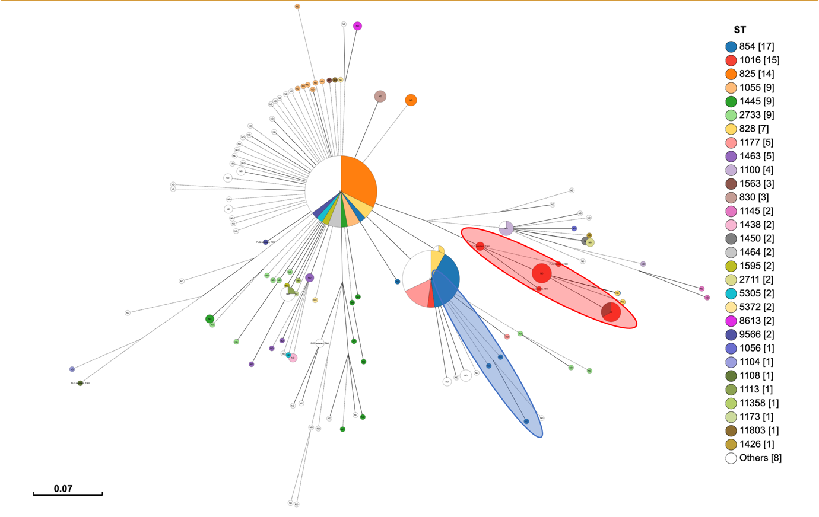

Figure 2: Minimum spanning tree of the 209 *C. coli* isolates from finisher pigs, based on MLST profiles. The tree was constructed based on shared alleles between the isolates, as per MLST analysis. The red circled clade indicates a fluoroquinolone resistant cluster and their corresponding ST-1016. The blue circled clade indicates the dominant ST in this study, ST-854.

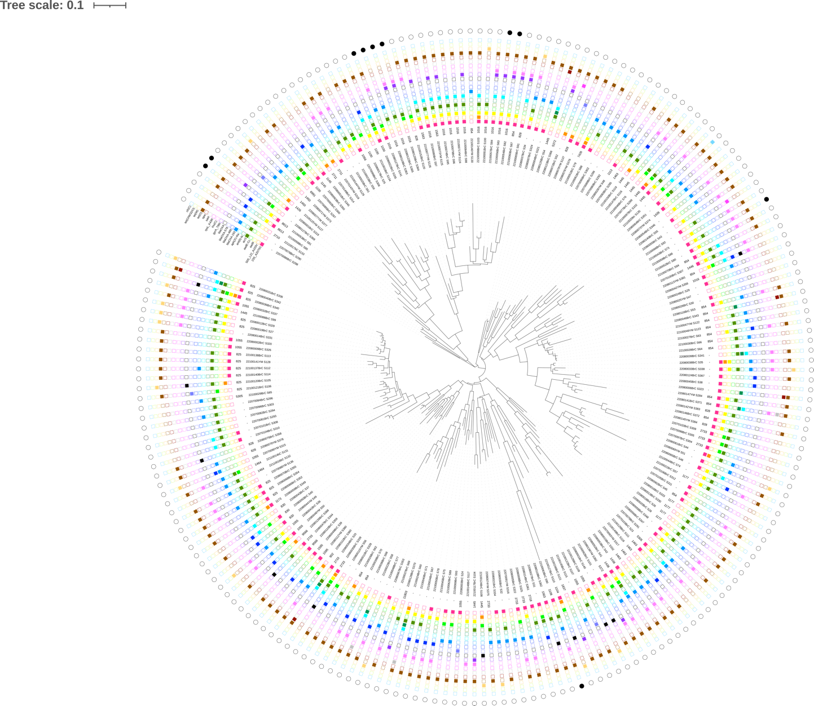

Figure 4: Phylogenetic analysis of the 209 strains of *C. coli* in this study, the branching out clades indicated the vast diversity across the core genomes of *C. coli* isolated from Australia. The outermost ring represents strains marked as fluoroquinolone (FQR) resistant, resistant markers were as indicated within figure.

.

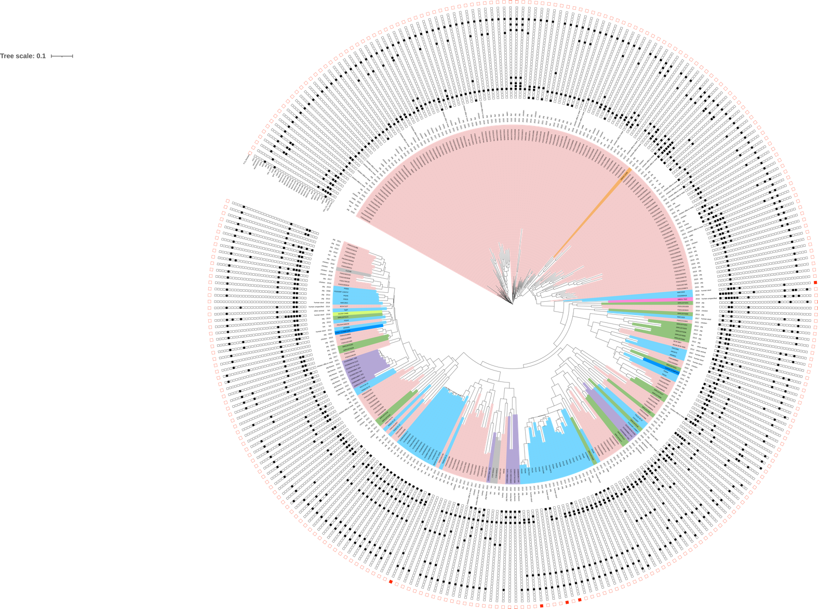

Figure 5: Core genome analysis of genomes belonging to ST-854, combining strains in this study (*n* = 17) and publicly available genomes (*n* = 247) obtained from PubMLST. Light pink shaded branches indicated strains isolated from the United States of America (USA), light blue shaded branches were from United Kingdom (UK), orange shaded branches were from India, dark pink shaded branches were from Vietnam, dark blue shaded branches were from Spain, dark green shaded branches were from Italy, light green branches were from Portugal, grey shaded branches were from Switzerland and purple shaded branches were strains from this study. The outermost ring in red indicated fluoroquinolone resistant strains as reported in metadata from PubMLST.

The presence of virulence genes determines the ability of *Campylobacter* isolates to adhere and invade cells and play a key role in disease development [33]. In this study, we observed the high prevalence of the *flh*A, *cia*B, *cad*F and *fla*A genes responsible for adherence and gut colonization, the invasiveness and motility of *Campylobacter* respectively [22]. Adherence is the primary step in infection and appears to be a prerequisite for invasion in most cases. However, the *cdt* genes responsible for toxin production and hence disease development was not detected, and neither were the w*LAN* genes that are responsible for Guillain-Barre syndrome. The frequency of virulence factors observed emphasizes the need for continued monitoring and surveillance of *Campylobacter* virulence genes from foods of animal origin in order to quickly detect virulence genes in livestock production and ultimately in animal products.

# 4.0 CONCLUSION

*Campylobacter* is an important zoonotic bacterium and can cause human diarrhoeal disease. The high prevalence and resistance to critically important antimicrobials (macrolides and fluoroquinolones) is a cause for concern as it limits treatment options. Particularly the resistance to fluoroquinolones in the absence of use requires further investigation. Other avenues for treatment such as ethnoveterinary medicine can be explored in a bid to reduce resistance of *C*. *coli* to these antibiotics. The overlap of ST between species underscores the zoonotic importance of *Campylobacter*. Therefore, it is important to employ a one health approach that encompasses the complexity of zoonotic bacteria and AMR in order to prevent and mitigate public health risks. Continuous monitoring of antimicrobial use and virulence genes would go a long way to protect public health and prevent the rise of AMR.

# References

[1] Kaakoush NO, Castano-Rodriguez N, Mitchell HM, Man SM. Global Epidemiology of Campylobacter Infection. Clin Microbiol Rev. 2015;28:687-720.

[2] Moore JE, Madden RH. Occurrence of Thermophilic Campylobacter spp. in Porcine Liver in Northern Ireland. Journal of Food Protection. 1998;61:409-13.

[3] Luangtongkum T, Jeon B, Han J, Plummer P, Logue CM, Zhang Q. Antibiotic resistance in Campylobacter: emergence, transmission and persistence. Future Microbiol. 2009;4:189-200.

[4] Hansson I, Sandberg M, Habib I, Lowman R, Engvall EO. Knowledge gaps in control of Campylobacter for prevention of campylobacteriosis. Transbound. Emerg. Dis. 65(Suppl. 1):30–48. Transbound Emerg Dis. 2018;65:30-48.

[5] Thakur S, Gebreyes WA. Campylobacter coli in swine production: antimicrobial resistance mechanisms and molecular epidemiology. J Clin Microbiol. 2005;43:5705-14.

[6] Steinhauserova I, Fojtikova K, Matiašovic J. Subtyping of Campylobacter Spp Strains and their Incidence in Piglets. Acta Vet Brno 70: 197–20. 2001;70.

[7] Carrique-Mas JJ, Bryant JE, Cuong NV, Hoang NV, Campbell J, Hoang NV, et al. An epidemiological investigation of Campylobacter in pig and poultry farms in the Mekong delta of Vietnam. Epidemiol Infect. 2014;142:1425-36.

[8] Assiene SDO, Ngah E, Ayangma RC, Ndjonka D. Prevalence of Campylobacter spp. Isolated from Pigs in Three Slaughterhouses of Yaounde Cameroon. Advances in Microbiology. 2021;11:213-24.

[9] World Organisation for Animal Health (OIE). OIE Annual Report on Antimicrobial Agents intended for Use in Animals- Better understanding of the global situation. 5th Report ed. Paris, France: World Organisation for Animal Health; 2021.

[10] World Health Organization. Critically important antimicrobials for human medicine: ranking of antimicrobial agents for risk management of antimicrobial resistance due to non-human use. Geneva, Switzerland: World Health Organization; 2017.

[11] Ghimire L, Singh DK, Basnet HB, Bhattarai RK, Dakal S, Sharma B. Prevalence, antibiogram and risk factors of thermophilic campylobacter spp. in dressed porcine carcass of Chitwan, Nepal. BMC Microbiology. 2014;14.

[12] Sithole V, Amoako DG, Abia ALK, Perrett K, Bester LA, Essack SY. Occurrence, Antimicrobial Resistance, and Molecular Characterization of Campylobacter spp. in Intensive Pig Production in South Africa. Pathogens. 2021;10.

[13] Cribb DM, Varrone L, Wallace RL, McLure AT, Smith JJ, Stafford RJ, et al. Risk factors for campylobacteriosis in Australia: outcomes of a 2018-2019 case-control study. BMC Infect Dis. 2022;22:586.

[14] Abraham S, O'Dea M, Page SW, Trott DJ. Current and future antimicrobial resistance issues for the Australian pig industry. Animal Production Science. 2017;57.

[15] Mukerji S, Stegger M, Truswell AV, Laird T, Jordan D, Abraham RJ, et al. Resistance to critically important antimicrobials in Australian silver gulls (Chroicocephalus novaehollandiae) and evidence of anthropogenic origins. J Antimicrob Chemother. 2019;74:2566-74.

[16] Abraham S, Sahibzada S, Hewson K, Laird T, Abraham R, Pavic A, et al. Emergence of Fluoroquinolone-Resistant Campylobacter jejuni and Campylobacter coli among Australian Chickens in the Absence of Fluoroquinolone Use. Appl Environ Microbiol. 2020;86.

[17] Meat & Livestock Australia. State of the industry report. North Sydney, Australia: Meat & Livestock Australia; 2019.

[18] Truswell A, Abraham R, O'Dea M, Lee ZZ, Lee T, Laird T, et al. Robotic Antimicrobial Susceptibility Platform (RASP): a next-generation approach to One Health surveillance of antimicrobial resistance. J Antimicrob Chemother. 2021;76:1800-7.

[19] Laird TJ, Jordan D, Lee ZZ, O'Dea M, Stegger M, Truswell A, et al. Diversity detected in commensals at host and farm level reveals implications for national antimicrobial resistance surveillance programmes. J Antimicrob Chemother. 2022;77:400-8.

[20] O’Dea M, Sahibzada S, Jordan D, Laird T, Lee T, Hewson K, et al. Genomic, antimicrobial resistance, and public health insights into Enterococcus spp. from Australian chickens. J Clin Microbiol. 2019;57.

[21] Gharbi M, Bejaoui A, Ben Hamda C, Ghedira K, Ghram A, Maaroufi A. Distribution of virulence and antibiotic resistance genes in Campylobacter jejuni and Campylobacter coli isolated from broiler chickens in Tunisia. J Microbiol Immunol Infect. 2022;55:1273-82.

[22] Rossler E, Olivero C, Soto LP, Frizzo LS, Zimmermann J, Rosmini MR, et al. Prevalence, genotypic diversity and detection of virulence genes in thermotolerant Campylobacter at different stages of the poultry meat supply chain. Int J Food Microbiol. 2020;326:108641.

[23] Wysok B, Wojtacka J. Detection of virulence genes determining the ability to adhere and invade in Campylobacter spp. from cattle and swine in Poland. Microb Pathog. 2018;115:257-63.

[24] Tadesse DA, Wittum T, Bahnson PB, DeGraves F, Funk JA, Thakur S, et al. Prevalence and Antimicrobial Resistance Profile of Campylobacter spp. Isolated from Conventional and Antimicrobial-Free Swine Production Systems from Different U.S. Regions. Foodborne Pathog Dis. 2011;8:367-74.

[25] Burrough E, Terhorst S, Sahin O, Zhang Q. Prevalence of Campylobacter spp. Relative to Other Enteric Pathogens in Grow-Finish Pigs with Diarrhea Anaerobe. 2013;22:111-4.

[26] Denis M, Chidaine B, Laisney M-J, Kempf I, Rivoal K, Mégraud F, Fravalo P. Comparison of Genetic Profiles of Campylobacter Strains Isolated from Poultry, Pig and Campylobacter Human Infections in Brittany, France Pathologie Biologie. 2009;57:23-9.

[27] Walker LJ, Wallace RL, Smith JJ, Graham T, Saputra T, Symes S, et al. Prevalence of Campylobacter coli and Campylobacter jejuni in Retail Chicken, Beef, Lamb, and Pork Products in Three Australian States. J Food Prot. 2019;82:2126-34.

[28] Wallace RL, Bulach D, McLure A, Varrone L, Jennison AV, Valcanis M, et al. Antimicrobial Resistance of *Campylobacter* spp. Causing Human Infection in Australia: An International Comparison. Microb Drug Resist. 2021;27.

[29] Hart WS, Heuzenroeder MW, Barton MD. Antimicrobial Resistance in *Campylobacter* spp., *Escherichia* coli and Enterococci Associated with Pigs in Australia. J Vet Med. 2004;B51:216-21.

[30] Lee T, Jordan D, Sahibzada S, Abraham R, Pang S, Coombs GW, et al. Antimicrobial resistance in porcine enterococci in Australia and the ramifications for human health. Applied and Environmental Microbiology. 2021;87.

[31] Kempf I, Kerouanton A, Bougeard S, Nagard B, Rose V, Mourand G, et al. Campylobacter coli in Organic and Conventional Pig Production in France and Sweden: Prevalence and Antimicrobial Resistance. Front Microbiol. 2017;8:955.

[32] Wallace RL, Bulach DM, Jennison AV, Valcanis M, McLure A, Smith JJ, et al. Molecular characterization of Campylobacter spp. recovered from beef, chicken, lamb and pork products at retail in Australia. PLoS One. 2020;15:e0236889.

[33] Ngobese B, Zishiri OT, El Zowalaty ME. Molecular detection of virulence genes in Campylobacter species isolated from livestock production systems in South Africa. Journal of Integrative Agriculture. 2020;19:1656-70.