**Appendix E**

COMING TO GRIPS WITH GREASY PIG DISEASE: A DETAILED ANALYSIS OF A PORCINE EXUDATIVE EPIDERMITIS OUTBREAK

Alec Truswell1, David Jordan1,3, Stanley Pang1, Tanya Cherrington1, David J. Hampson1, John Blinco1, Sandy Adsett2, Rebecca Abraham1, Marc Stegger1,3, Sam Abraham1*

1Antimicrobial Resistance and Infectious Diseases Laboratory, Harry Butler Institute, Murdoch University, Murdoch, WA, Australia

2Rivelea Australia Pty Ltd, VIC, Australia

3Department of Sequencing and Bioinformatics, Statens Serum Institut, Copenhagen, Denmark

*Correspondence: [s.abraham@murdoch.edu.au](mailto:s.abraham@murdoch.edu.au)

ABSTRACT

Exudative epidermitis (EE) poses significant challenges to the pig industry due to resultant high morbidity and mortality rates in piglets. This study examined the microbial ecology, antimicrobial resistance, and genetic diversity of *Staphylococcus hyicus* isolates from EE skin lesions during an outbreak in an Australian piggery. A total of 160 bacterial isolates from 20 pigs—comprising *S. hyicus* and other cohabiting species—were subjected to phenotypic and whole genome sequencing (WGS) analyses to assess species identity, antimicrobial resistance, virulence factors, and phylogenetic relationships.

*S. hyicus* was the predominant species recovered from EE lesions. Antimicrobial susceptibility testing revealed varied resistance profiles, with notable resistance to erythromycin and tetracycline. Whole genome sequencing identified four distinct genotypic antimicrobial resistance profiles among *S. hyicus* isolates, including some conferring resistance to multiple antimicrobial classes. All *S. hyicus* isolates carried the exfoliative toxin gene *sheta*, while 24 also carried *exhD*. Core genome phylogenetic analysis revealed that 24 of the 27 sequenced *S. hyicus* isolates were genetically identical, indicating a highly clonal outbreak.

These findings suggest the outbreak was driven by a single, stable *S. hyicus* clone. The methodology and results presented here have important implications for EE outbreak investigation, prevention, and management—highlighting the value of regular, multi-isolate sampling to capture variation in antimicrobial susceptibility and inform both treatment strategies and the potential development of autogenous vaccines targeting dominant outbreak clones.

KEYWORDS

Antimicrobial resistance; Exudative epidermitis; Outbreak; Pigs; *Staphylococcus hyicus*.

HIGHLIGHTS

* Porcine exudative epidermitis lesions are prone to complex bacterial ecology.
* Antimicrobial resistance varied within a clonal outbreak of *Staphylococcus hyicus*.
* A subset of isolates exhibited multiclass antimicrobial resistance.
* Multi-isolate sampling can inform antimicrobial therapy and autogenous vaccines.

INTRODUCTION

Exudative epidermitis (EE), otherwise known as Greasy Pig Disease, is a sporadic condition affecting young piglets that results in economic loss and welfare concerns to the pig industry [1]. EE causes high morbidity and mortality rates in piglets, with up to 90% mortality in severely affected litters, where death is often seen within 48 hours [2]. *Staphylococcus hyicus* is the most prominent causative organism involved, although anecdotally other *Staphylococcus* species have been implicated [3].

As a natural commensal of the skin, nose and ears, *S. hyicus* can opportunistically capitalise on minor abrasions to invade and initiate disease [2, 4]. An important determining factor in the initiation of disease is the possession of exfoliative toxin-producing virulence factors, encoded by *exhA*, *exhB*, *exhC*, *exhD*, *sheta* and *shetb* [1, 4]. These exfoliative toxins are serine proteases that digest porcine desmoglein-1, disrupting cell-to-cell junctions and splitting the epidermis [4]. There is an exfoliated, reddened, and thickened appearance to the skin at the affected site, often resulting in failure to thrive, dehydration, and death in piglets [4].

Given the pathognomonic nature of the disease, confirmatory testing – via the isolation and identification of a single *S. hyicus* colony from a lesion – is the standard diagnostic approach [2]. It is known that isolates of other bacterial pathogens such as *Escherichia coli*, recovered from individual pigs, may demonstrate considerable clonal diversity which can extend to phenotypic antimicrobial susceptibilities [5]. As staphylococci can acquire and exchange genetic material [6, 7] and are physically predisposed to cross-species interaction (i.e., environmental, faecal), the authors hypothesise that staphylococci involved in EE outbreaks may exhibit within-host heterogeneity, making them more difficult to manage than presently anticipated. The present study explored this hypothesis using a robotics-enabled multisampling approach, tasked with thoroughly evaluating the microbial ecology of EE lesions within an individual herd during a suspected ongoing outbreak. Through incorporating robotics, we achieved a substantial increase in the number of pigs and isolates assessed beyond standard clinical practice to deliver accurate herd-level disease classification and, thus, a robust basis for vaccine selection. This high-resolution evaluation of the ecology of pathogens at the herd level is invaluable for guiding antimicrobial stewardship and future industry-wide surveillance of porcine bacterial pathogens.

METHODS

Epidermal lesion swab samples from 20 individual weaner pigs were collected by a veterinarian at a single Australian piggery experiencing an outbreak of EE. Pigs were from different litters and were selected based on the presence of active skin lesions. Each swab was immersed in 1 mL PBS and subsequently diluted. Several diluted inocula were plated on Columbia Sheep Blood Agar (MM1100, Edwards) to obtain single colonies using the Robotic Antimicrobial Susceptibility Platform (RASP) on the Tecan EVO 150 (Tecan and Scirobotics), utilising the two-ring dilution protocol as previously described [8].

After overnight incubation at 37°C, eight resultant bacterial colonies per agar plate were subcultured in Brain Heart Infusion broth (Oxoid) using the RASP-integrated Pickolo colony picking software (Scirobotics). MALDI-TOF (Bruker) was used to determine the species of each isolate.

The following day, broth microdilution antimicrobial susceptibility testing was performed on all isolates (n = 160 from 20 swabs), as per the RASP method [8], using the following antimicrobials (antimicrobial class indicated in brackets): apramycin (aminoglycoside), cefoxitin (cephems), ciprofloxacin (fluoroquinolone), erythromycin (macrolide), florfenicol (amphenicol), gentamicin (aminoglycoside), lincomycin (lincosamide), oxacillin (beta-lactam), penicillin G (penicillins), rifampicin (ansamycin), tetracycline (tetracycline), and trimethoprim-sulfamethoxazole (folate pathway inhibitor). Non-susceptibility was assessed using CLSI clinical breakpoints [9], or EUCAST ECOFF values (<https://mic.eucast.org/>) where clinical breakpoints were unavailable.

*Whole genome sequencing*

A subset of 27 *S. hyicus* isolates from 19 of the pigs were subjected to whole genome sequencing (WGS). Isolates were chosen to ensure the inclusion of each unique phenotypic antimicrobial resistance profile. The MagMAX-96 DNA Multi-Sample Kit (Applied Bio Systems, Thermo Fisher Scientific) was used for DNA extraction on the MagMAX 96-well automated extraction platform (Life Technologies) according to manufacturer’s instructions. WGS was performed using the NextSeq500/550 Mid Output 2x150 Reagent Cartridge v2 (Illumina) to obtain paired-end 2x150 reads. Sequence data was *de novo* assembled using SPAdes (v3.14.1). AMR genes were identified using ABRicate (v1.0.1) (https://github.com/tseemann/abricate) via the publicly available ResFinder database (accessed November 2022), with identified AMR genes considered present if they were at greater than 95% coverage and identity. Virulence factors were screened for using ABRicate with a custom database consisting of the following genes: *exhA*, *exhB*, *exhC*, *exhD, sheta* and *shetb* (GenBank accession numbers AF515453, AF515454, AF515455, AF515456, AB036768 and AB036767 respectively) [10].

*Phylogenetic analysis*

Isolates from the present study were phylogenetically compared with all publicly available *S. hyicus* genome sequences on NCBI (https://www.ncbi.nlm.nih.gov/datasets/genome/), accessed August 2024 (Table S1). Core single-nucleotide polymorphisms (SNPS) were identified using Snippy v4.1.0, with all isolate genomes aligned to the *S. hyicus* ATCC 11249 reference genome (accession: GCA_000816085.1) under default parameters. Core SNP alignments were generated using Snippy-core and used to infer a maximum likelihood phylogeny. Recombination was removed using ClonalFrameML v1.11. The final tree was constructed with RAxML v8.2.11 using the GTR+CAT model and 1,000 rapid bootstrap replicates. The tree was midpoint-rooted and visualised in iTOL v6.5.8. Branch lengths were expressed as substitutions per site. Pairwise SNP distances between isolates were calculated from the core genome alignment using SNP-dists v0.6.

RESULTS

*Lesion ecology*

*S. hyicus* was the most frequently identified species from the 20 lesion swabs that were screened. This species accounted for 55% (88/160) of the isolated colonies from 19 of the samples and was the predominant organism in 13 of the lesion swabs (Figure 1). Two other members of the porcine native skin flora, *Staphylococcus chromogenes* and *Staphylococcus aureus,* were identified in lower proportions at 11% (n = 18 from ten pigs) and 8% (n = 12 from seven pigs) respectively. Non-staphylococcal organisms (designated ‘other’) comprised *Streptococcus suis*, *E. coli* and *Rothia nasimurium,* which accounted for 26% (n = 42) of the isolates.

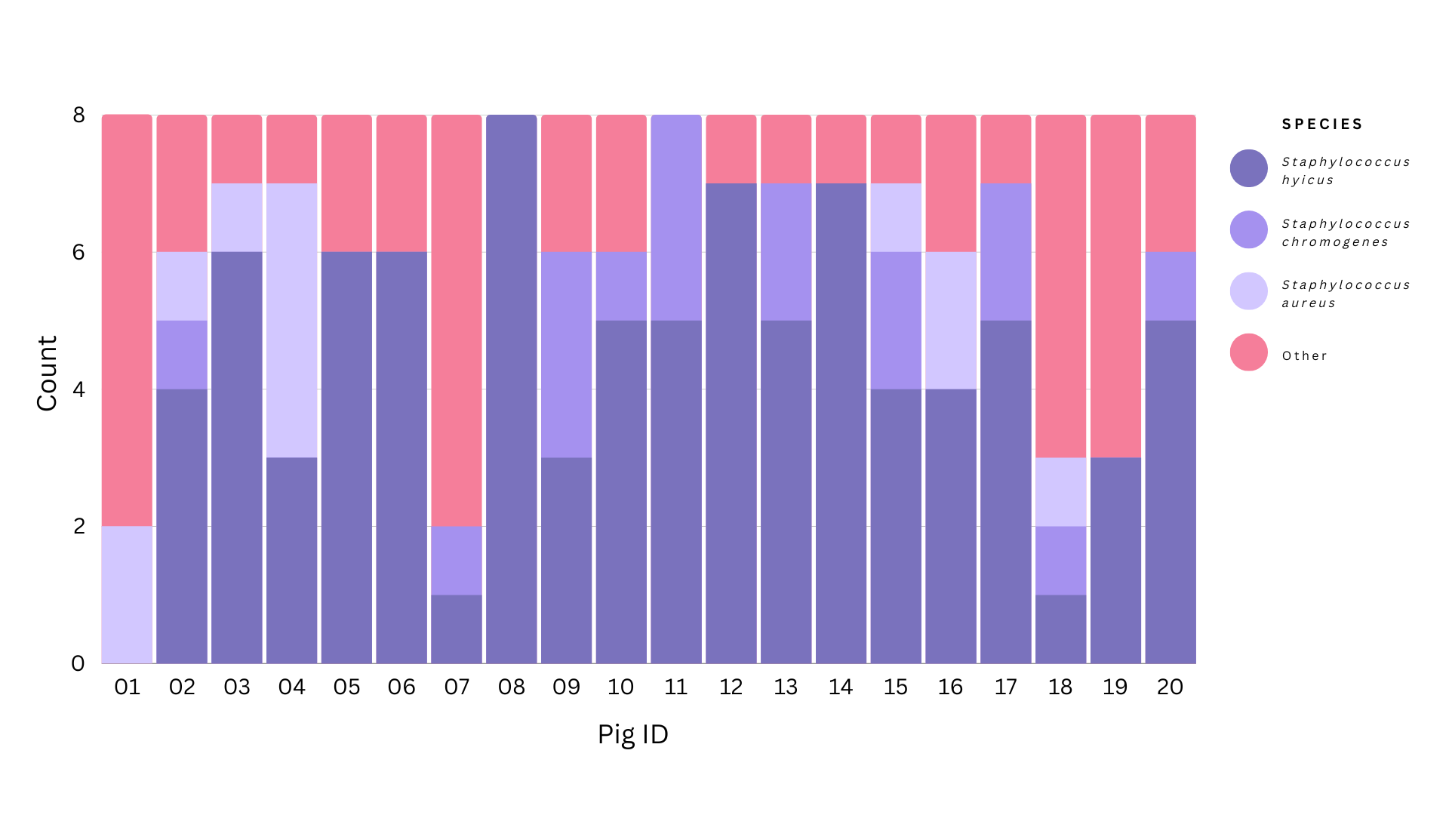

**Figure 1** | Intra-lesion bacterial diversity of porcine exudative epidermitis lesion swabs obtained from 20 individual pigs. Eight colonies per lesion swab were identified to species level, and their frequency within and between pigs was noted. ‘Other’ denotes non-staphylococcal species.

*Antimicrobial resistance phenotypes*

Seven unique phenotypic resistance profiles were identified among 88 *S. hyicus* isolates, where the most common (54.5%) demonstrated resistance to both erythromycin and tetracycline (Table 1). Clinical breakpoints for lincomycin and florfenicol were not available; however, using EUCAST ECOFF values, 100% and 87.5% of *S. hyicus* isolates were classified as non-wild type against lincomycin and florfenicol, respectively. Isolates derived from the same pig lesion often demonstrated different resistance profiles, with up to four unique profiles seen within an individual lesion (Table S2). Multiclass resistance (based on CLSI clinical breakpoints) was observed in 5.7% of *S. hyicus* isolates: 3.4% were resistant to three antimicrobial classes, and 2.3% were resistant to four antimicrobial classes. Several *S. aureus*, *S. chromogenes* and non-staphylococcal isolates derived from the lesions swabs also exhibited multiclass resistance, with some overlap in resistance profiles noted between species (Tables 1, S3-S7).

**Table 1** | Phenotypic resistance profiles of Staphylococcus hyicus (n = 88) isolated from Australian porcine skin lesions.

|  |  |  |
| --- | --- | --- |
| **Phenotypic resistance profile** | **Number of antimicrobial classes** | **Number of isolates (%)** |
| n/a | 0 | 2 (2.3) |
| tet | 1 | 31 (35.2) |
| ery-tet | 2 | 48 (54.5) |
| ery-pen | 2 | 2 (2.3) |
| ery-pen-tet | 3 | 2 (2.3) |
| ery-sxt-tet | 3 | 1 (1.1) |
| ery-pen-sxt-tet | 4 | 2 (2.3) |

Abbreviations: ery = erythromycin; pen = penicillin; sxt = co-trimoxazole; tet = tetracycline.

*Antimicrobial resistance genotyping*

Of the 27 *S. hyicus* subjected to WGS, five unique genotypic antimicrobial resistance profiles were identified (Table 2). The profiles included genes known to convey resistance to beta-lactam, diaminopyrimidine, lincosamide, macrolide, pleuromutilin, streptogramin and tetracycline antimicrobial classes. All five profiles (n = 27) harboured antimicrobial resistance genes (ARGs) directed against four or more antimicrobial classes. The *tet(K)* ARG was detected commonly throughout isolates, except for one which instead carried a *tet(L)* gene, and a subset of three isolates that lacked any tetracycline resistance genes. The isolate carrying *tet(L)* also differed in its carriage of *erm(T)*, where others possessed *erm(C)*. Additionally, the *dfrG* gene was detected in only a single isolate, which carried the highest number of ARGs.

**Table 2** | Genotypic resistance profiles of Staphylococcus hyicus (n = 27) isolated from Australian porcine skin lesions.

|  |  |  |
| --- | --- | --- |
| **Genotypic resistance profile** | **Number of antimicrobial classes** | **Number of isolates (%)** |
| *blaZ - lnu(B) – lsa(E)* | 4 | 3 (11.1) |
| *blaZ - lnu(B) - lsa(E) - tet(K)* | 5 | 11 (40.7) |
| *blaZ - lnu(B) - lsa(E) - erm(C) - tet(K)* | 6 | 11 (40.7) |
| *blaZ - lnu(B) - lsa(E) - erm(T) - tet(L)* | 6 | 1 (3.7) |
| *blaZ – dfrG - lnu(B) - lsa(E) - erm(C) - tet(K)* | 7 | 1 (3.7) |

Antimicrobial class resistance conveyed by each resistance gene: blaZ = beta-lactam; lnu(B) = lincosamide; lsa(E) = pleuromutilin, streptogramin, lincosamide; tet(K) and tet(L) = tetracycline; erm(C) and erm(T) = streptogramin, lincosamide, macrolide; dfrG = diaminopyrimidine [11].

*Virulence*

Genes encoding exfoliative toxin-producing virulence factors were detected in all 27 sequenced *S. hyicus* isolates. Twenty-four isolates carried both *shet*aand *exh*D virulence factor genes, while three isolates carried only *shet*a.

*Phylogenetic analysis*

The 27 *S. hyicus* isolates from the present study were phylogenetically distinct from the NCBI-sourced sequences. Their closest neighbours were a cluster of four *S. hyicus* isolates; threeisolates from skin lesions in Australian cattle and a single porcine skin isolate from China (Figure 2). Those differed by 40 and 32 SNPS, respectively, from the closest isolate of this study (Table S8). Among these 27 isolates, 24 were genetically identical with no SNPs different between them (Figure 2, Table S8). Despite this, they exhibited variation in ARG carriage, presenting three different genotypic resistance profiles based on the presence or absence of *tet(K)* and *erm(C)*.

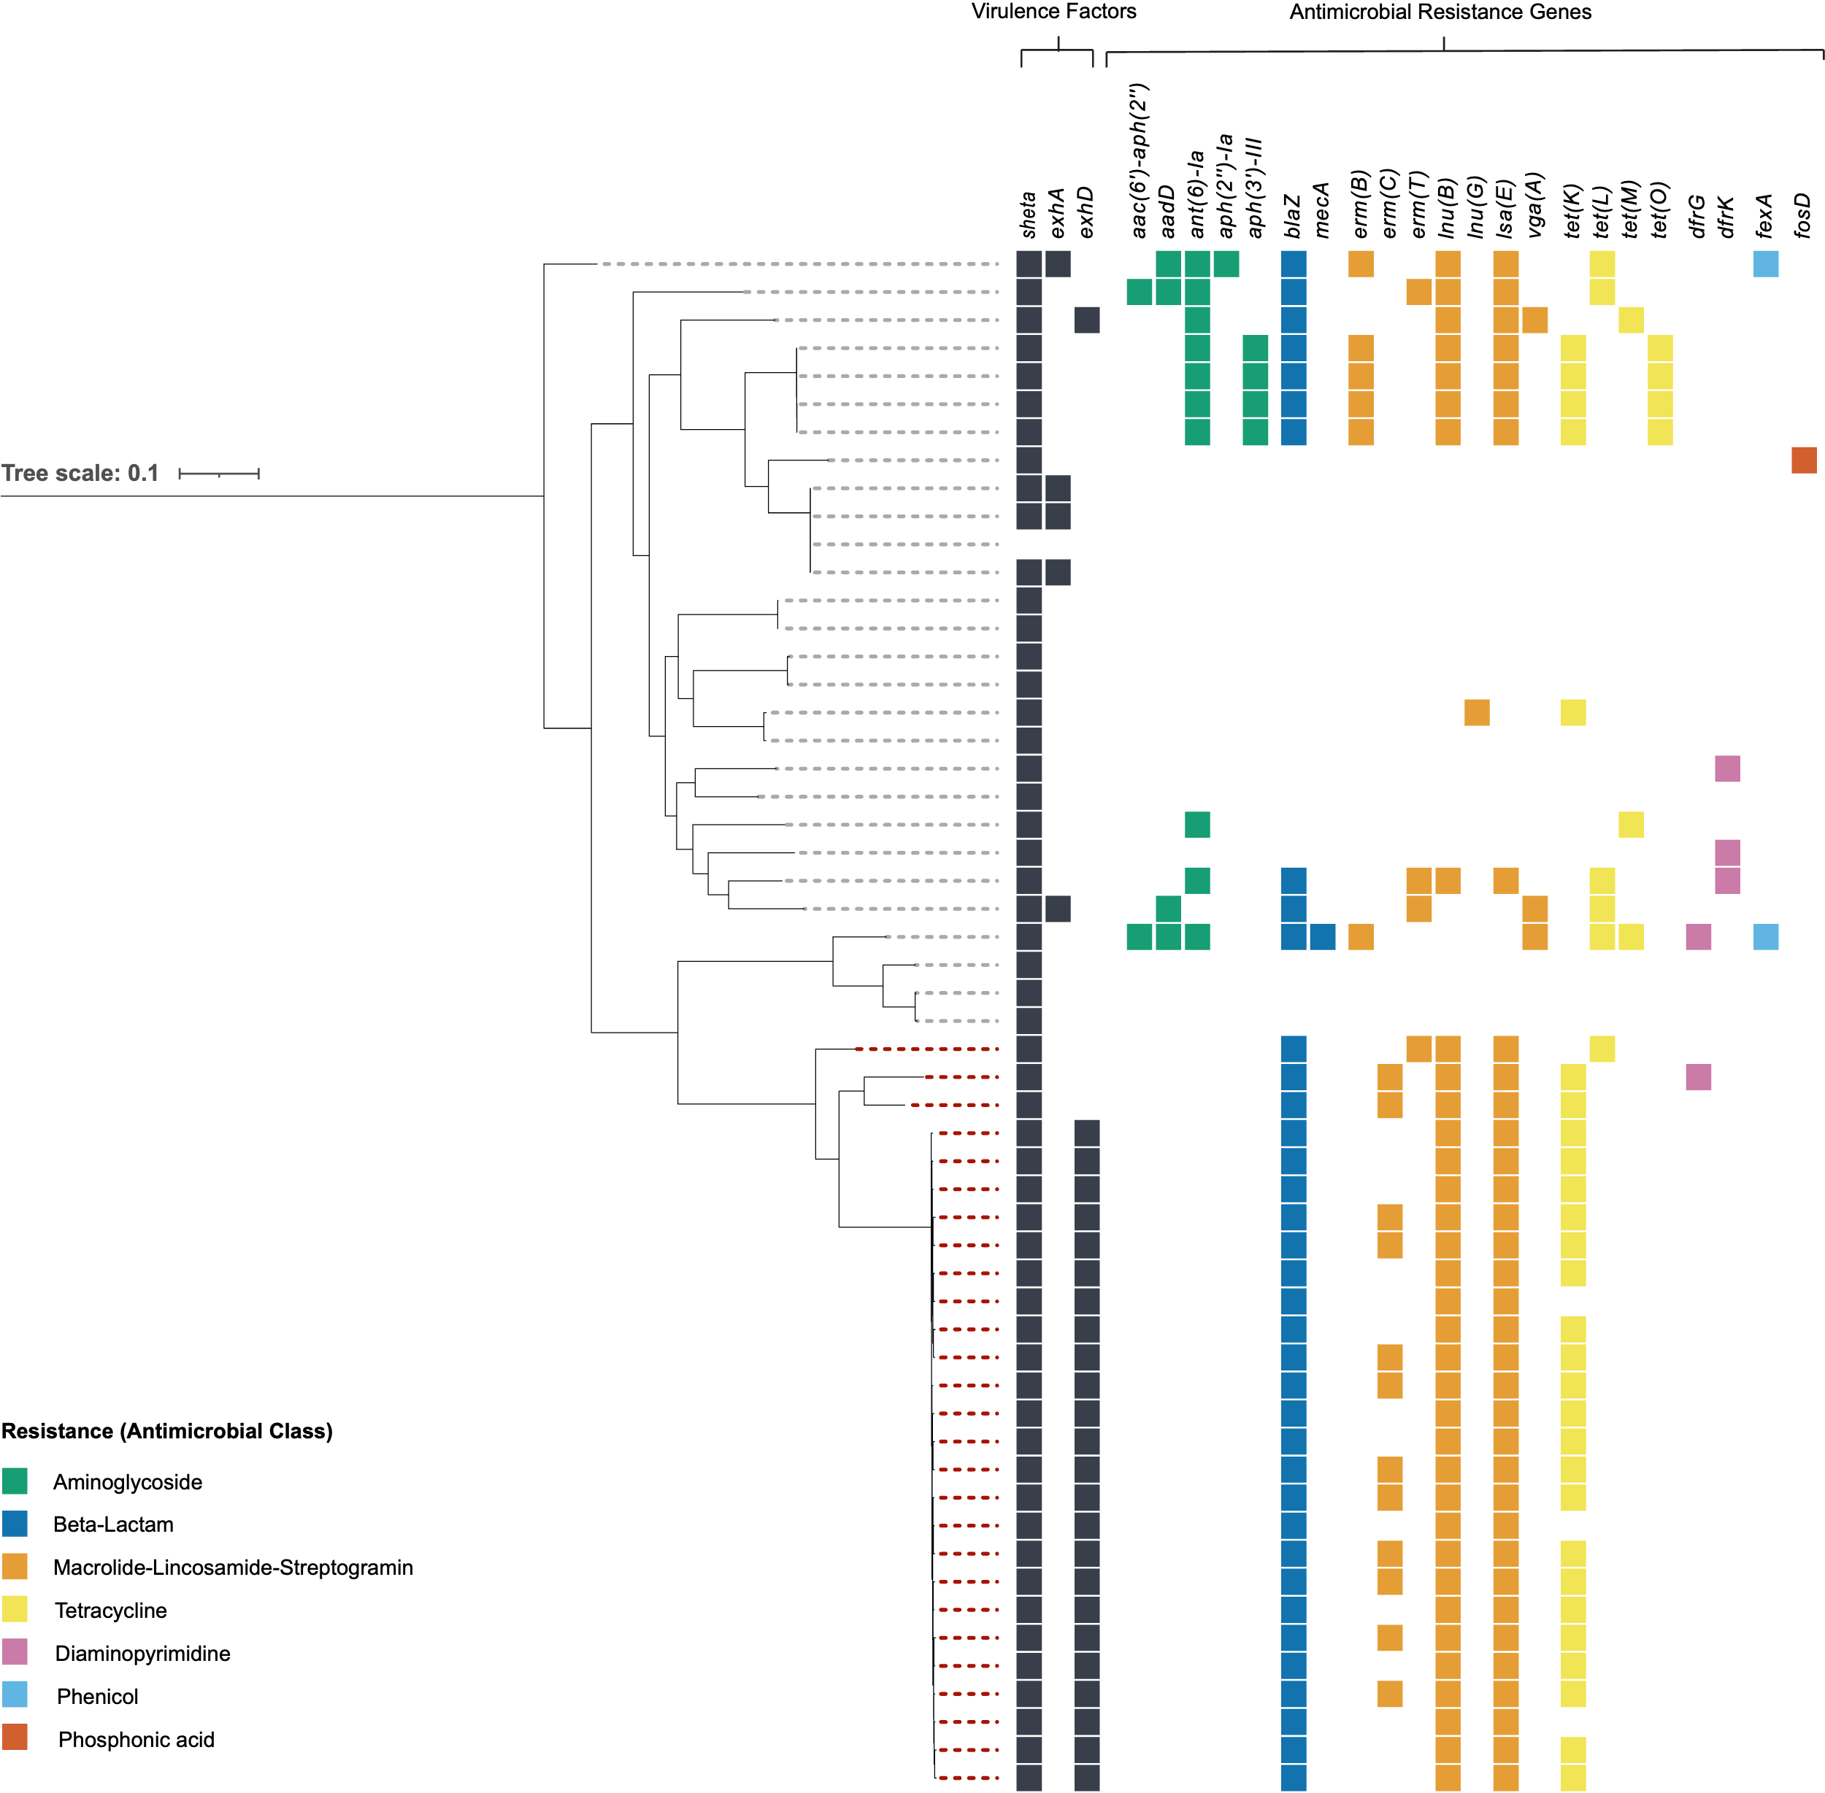

**Figure 2** | Midpoint-rooted maximum likelihood phylogeny comparing *Staphylococcus hyicus* isolates from an exudative epidermitis outbreak in Australian pigs (red dashed line, n = 27) with all publicly available *S. hyicus* genome sequences from NCBI (grey dashed line, n = 27). The tree was constructed using 941 core genome SNPs, and the scale bar indicates substitutions per site.

DISCUSSION

In the absence of a formal strain typing scheme for *Staphylococcus hyicus*, 27 isolates from a single putative outbreak underwent whole-genome phylogenetic analysis to assess clonality. This revealed that 24 isolates were genetically indistinguishable, with no core genome SNP differences between them (Figure 2, Table S8). The remaining three isolates were more distantly related, suggesting they may represent unrelated background strains or separate introductions. The complete genetic identity among the 24 isolates suggests a recent clonal expansion from a common source, indicating that a single clone was responsible for the outbreak. If similar patterns are observed in future EE outbreaks, this could have important implications for management strategies, particularly through the implementation of genomic surveillance and the development of targeted autogenous vaccines derived from locally circulating clones.

Broad-spectrum antimicrobial resistance is a commonly noted feature of *S. hyicus* [12, 13]*,* and autogenous vaccination has been previously explored as an additional tool for managing EE outbreaks, but with varying degrees of success [4, 13]. These previous vaccine development efforts have been informed purely by virulence factor genotype and are typically based on a small number of isolates per outbreak, which may not be a reliable predictor of vaccine efficacy. These outcomes could perhaps be improved if vaccine design considered the entire organism (via WGS-based approaches), where all components of the organism involved in immune system recognition (known and unknown) may also be inadvertently included. Moreover, evaluation of the extent of clonality in outbreaks is important, so that in cases where *S. hyicus* outbreaks are found to be clonal (such as in this study), autogenous vaccination could be worth exploring.

The overlap in antimicrobial resistance gene carriage observed among *S. hyicus* isolates in this study is consistent with the presence of a predominant outbreak clone. However, some isolates within this clonal group still exhibited gain or loss of antimicrobial resistance elements. The limited genotypic variation provides little support for the high levels of intraspecies AMR diversity reported in other organisms such as *E. coli* [5]. Nevertheless, even the limited genotypic diversity identified in this present study can complicate the management of *S. hyicus* outbreaks regarding antimicrobial treatment. If treatment is based on antimicrobial susceptibility diagnostics for a single isolate, it may not be representative of the range of potential antimicrobial resistance profiles present in the outbreak, and therefore be ineffective [5]. This risk can be lowered through increased sampling - i.e., the investigation of multiple isolates per lesion and multiple pigs per farm as exemplified in this present study.

The cutaneous location of porcine EE lesions predisposes them to a complex bacterial ecology, including opportunistic commensal flora (including *S. hyicus*) and contaminating organisms from the environment and from pen-mates. This prompts consideration of the interplay between all organisms occupying the lesion, particularly in terms of the potential for ARG exchange [14]. Non-*S. hyicus* species cohabiting the lesions investigated in this study exhibited various phenotypic antimicrobial resistances, with several demonstrating multiclass resistance (Tables S1 – S5). If these resistances are provided by ARGs on extrachromosomal elements, then there is potential for exchange with neighbouring *S. hyicus* isolates. Whole genome sequencing of cohabiting lesion flora was not undertaken in this study but should be considered in future investigations to assess the potential for exchange of extrachromosomal resistance elements.

In summary, this study suggests that the diagnostic protocol for EE outbreaks in pigs should consider if all the important microbial occupants of lesions will be detected and adequately characterised. Protocols involving more intensive sampling of pigs and isolates do increase the likelihood of correctly identifying the most appropriate antimicrobial therapy. With further surveillance of *S. hyicus* outbreaks, the value of autogenous vaccination can be gauged – based on the degree of homogeneity displayed in outbreaks – with the potential for implementation as an additional management tool. Multi-isolate sampling facilitated by high-throughput laboratory platforms becomes attractive in a diagnostic setting when bacterial ecology of lesions is complicated, and/or when there is substantial within-herd variation in colonisation.

CRediT AUTHORSHIP CONTRIBUTION STATEMENT

**Alec Truswell**: Conceptualisation, Methodology, Investigation, Data Curation, Formal Analysis, Visualisation, Writing – Original Draft. **David Jordan**: Conceptualisation, Methodology, Writing – Review and Editing. **Stanley Pang**: Formal Analysis, Writing – Review and Editing. **Tanya Cherrington**: Formal Analysis. **David J. Hampson**: Writing – Review and Editing. **John Blinco**: Investigation. **Sandy Adsett**: Investigation. **Rebecca Abraham**: Supervision. **Marc Stegger**: Formal Analysis, Writing – Review and Editing. **Sam Abraham**: Conceptualisation, Funding Acquisition, Resources, Methodology, Supervision.

DECLARATION OF COMPETING INTERESTS

Prof. Sam Abraham and Dr. Rebecca Abraham are Directors and scientific leads at Aquila Scientific, a start-up biotechnology company. They have previously received funding from several Australian livestock industry bodies, including Australasian Pork Research and Innovation Limited, Australian Eggs, and AgriFutures (Chicken Meat Program), as well as government agencies such as Food Standards Australia New Zealand, the Commonwealth Department of Agriculture, and the WA Department of Health. Their research has focused on developing robotics and antimicrobial resistance (AMR) testing for commensal and pathogenic organisms in humans, animals, and food.

FUNDING SOURCE(S)

Alec Truswell was supported by a PhD scholarship from Australian Pork Limited. This project was supported by Australian Pork Limited (APL) Project: *High throughput robotics for the management and control of antimicrobial resistance and endemic diseases in pigs* (2021/0039).

Prof. Sam Abraham was supported by a WA Near Miss Fellowship through the Future Health Research and Innovation (FHRI) Fund, Department of Health, Government of Western Australia (WANMA/EL2022/10).

ACKNOWLEDGEMENTS

N/A

REFERENCES

1. Frana TS, Hau SJ. Staphylococcosis. In: Zimmerman JJ, Karriker LA, Ramirez A, Schwartz KJ, Stevenson GW, Zhang J, editors. *Diseases of Swine*. 11th ed. Hoboken (NJ): Wiley-Blackwell; 2019. p. 926–33.

2. Quinn PJ, Markey BK, Leonard FC, Hartigan P, Fanning S, Fitzpatrick E. *Veterinary Microbiology and Microbial Disease*. 2nd ed. Hoboken (NJ): Wiley-Blackwell; 2011.

3. Park J, Friendship RM, Poljak Z, Weese JS, Dewey CE. An investigation of exudative epidermitis (greasy pig disease) and antimicrobial resistance patterns of *Staphylococcus hyicus* and *Staphylococcus aureus* isolated from clinical cases. *Can Vet J*. 2013;54(2):139.

4. Pickering AC, Haag AF, Penadés JR, Fitzgerald JR. Staphylococcus. In: Prescott JF, MacInnes JI, Van Immerseel F, Boyce JD, Rycroft AN, Vázquez-Boland JA, eds. *Pathogenesis of Bacterial Infections in Animals*. 5th ed. Hoboken (NJ): Wiley-Blackwell; 2022. p. 543–64.

5. Laird TJ, Jordan D, Lee ZZ, O’Dea M, Stegger M, Truswell A, et al. Diversity detected in commensals at host and farm level reveals implications for national antimicrobial resistance surveillance programmes. *J Antimicrob Chemother*. 2022;77(2):400–8. https://doi.org/10.1093/jac/dkab403

6. Schwarz S, Feßler AT, Loncaric I, Wu C, Kadlec K, Wang Y, et al. Antimicrobial resistance among staphylococci of animal origin. *Microbiol Spectr*. 2018;6(4). https://doi.org/10.1128/microbiolspec.ARBA-0010-2017

7. Ikhimiukor OO, Souza SSR, Marcovici MM, Nye GJ, Gibson R, Andam CP. Leaky barriers to gene sharing between locally co-existing coagulase-negative *Staphylococcus* species. *Commun Biol*. 2023;6(1):482. https://doi.org/10.1038/s42003-023-04877-0

8. Truswell A, Abraham R, O’Dea M, Lee ZZ, Lee T, Laird T, et al. Robotic Antimicrobial Susceptibility Platform (RASP): a next-generation approach to One Health surveillance of antimicrobial resistance. *J Antimicrob Chemother*. 2021;76(7):1800–7. https://doi.org/10.1093/jac/dkab126

9. Clinical and Laboratory Standards Institute. Performance standards for antimicrobial susceptibility testing. 21st informational supplement. CLSI document M100-S21. Wayne (PA): CLSI; 2011.

10. Onuma K, Uoya Y, Koide T, Shibata A, Tanabe T, Sato H. Detection of *Staphylococcus hyicus* exfoliative toxin genes by dot blot hybridization and multiplex polymerase chain reaction. *Microbiol Immunol*. 2011;55(3):168–73. https://doi.org/10.1111/j.1348-0421.2011.00308.x

11. Alcock BP, Huynh W, Chalil R, Smith KW, Raphenya AR, Wlodarski MA, et al. CARD 2023: expanded curation, support for machine learning, and resistome prediction at the Comprehensive Antibiotic Resistance Database. *Nucleic Acids Res*. 2023;51(D1):D690–9. https://doi.org/10.1093/nar/gkac920

12. Tetens J, Sprotte S, Thimm G, Wagner N, Brinks E, Neve H, et al. First molecular characterization of Siphoviridae-like bacteriophages infecting *Staphylococcus hyicus* in a case of exudative epidermitis. *Front Microbiol*. 2021;12:653501. https://doi.org/10.3389/fmicb.2021.653501

13. Arsenakis I, Boyen F, Haesebrouck F, Maes DGD. Autogenous vaccination reduces antimicrobial usage and mortality rates in a herd facing severe exudative epidermitis outbreaks in weaned pigs. *Vet Rec*. 2018;182(26):744. https://doi.org/10.1136/vr.104720

14. von Wintersdorff CJH, Penders J, van Niekerk JM, Mills ND, Majumder S, van Alphen LB, et al. Dissemination of antimicrobial resistance in microbial ecosystems through horizontal gene transfer. *Front Microbiol*. 2016;7:173. https://doi.org/10.3389/fmicb.2016.00173